** **

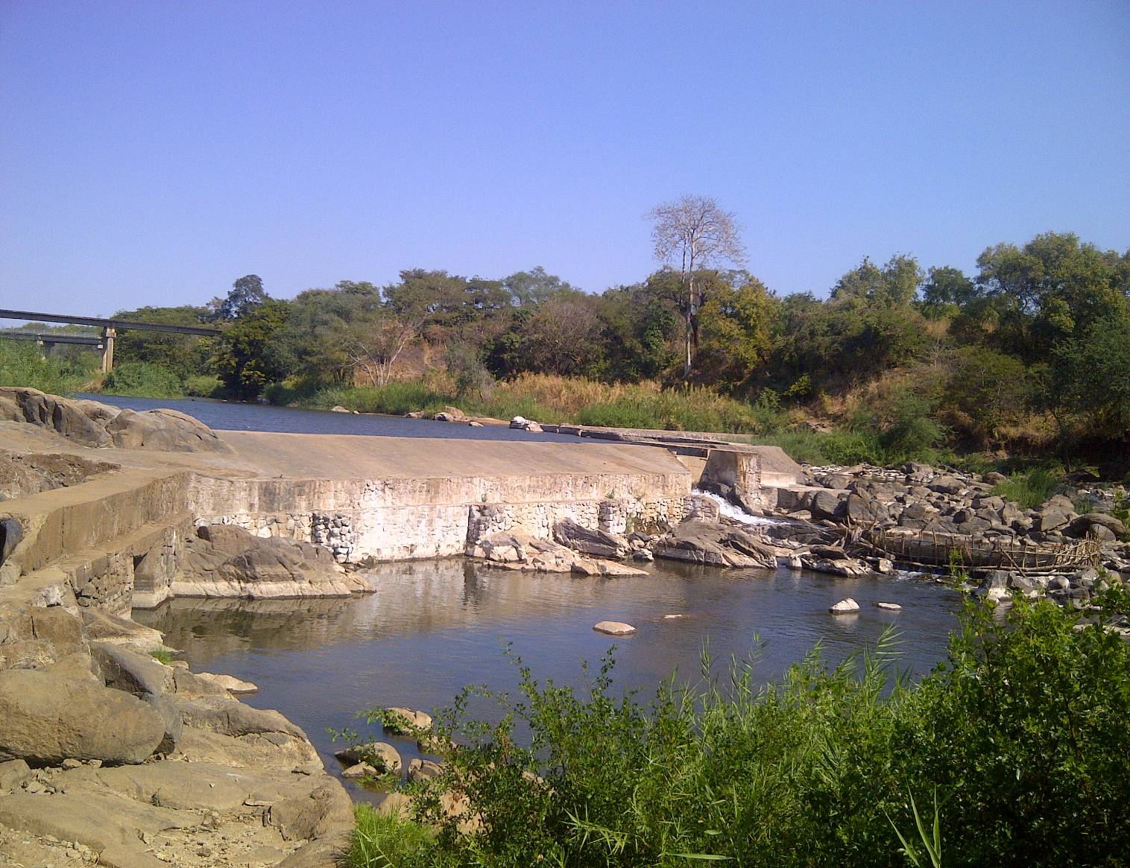

**MINISTRY OF AGRICULTURE, IRRIGATION AND WATER DEVELOPMENT**

**SALIMA IRRIGATION SERVICES DIVISION**

**DEPARTMENT OF IRRIGATION**

**ANNUAL REPORT**

**JULY 2017 TO JUNE 2018**

**THE DIVISION IRRIGATION OFFICER**

**SALIMA IRRIGATION SERVICES DIVISION**

**PRIVATE BAG 1**

**SALIMA.**

**TEL: +265885908187**

**Cel: +265 999226939/0884463943**

**JULY, 2018**

**TABLE OF CONTENTS**

List of tables 0

List of figures 0

List of annexes 0

Executive summary 1

1.0 INTRODUCTION 2

2.0 HUMAN AND FINANCIAL RESOURCES 3

2.1 Staffing for the ISD 3

2.2 Capacity building 4

2.4 Financial performance 4

2.4.1 ORT budget 5

2.4.2 Development budget 5

3.0 PHYSICAL IMPLEMENTATION PROGRESS 5

3.1 ANNUAL IMPLEMENTATIONPROGRESS 5

3.1.1 Construction of Irrigation schemes 5

3.1.2 Rehabilitation of irrigation schemes 6

3.1.3 Development of farmer organizations 6

3.2 Cumulative irrigation status 6

3.2.2 Motorized pump based Irrigation schemes 8

3.2.3 Treadle pump based Irrigation schemes 8

3.3 Collaboration with other stakeholders 9

3.4 Estate/private irrigation farming 9

4.0 PROGRESS ON DEVELOPMENT PROJECTS/ PROGRAMMES 9

# List of tables

*Table 1a: Established Staff Positions* 3

*Table 2: Motor Vehicles and Motor Cycles* 4

*Table 3: Financial performance by Cost Centre* 5

**Table 4: Summary of progress made under new scheme development** 6

Table 5: Breakdown of area under irrigation by technology; 7

Table 6: Summary of gravity fed irrigation schemes by water source 7

Table 7: Summary of motorized pump based irrigation schemes by water source 8

Table 8: Summary of Treadle pump based irrigation schemes by water source 8

# List of figures

# List of annexes

# Executive summary

*Salima Irrigation Services Division in the just ended financial year implemented many activities for both Other Recurrent Transaction (ORT) and development programs in both districts of Salima and Nkhotakota. A total of* ***71 ha*** *has been newly developed in the just ended financial year and 2777.20 ha has been put into utilisation of which 1070 ha was gravity fed, 397.9 ha was motorised pump based,and 284ha was under treadle pump and 126 ha was put under watering can benefiting 24,969 farmers of which 11,252 are female.*

*The division had an annual allocation of*  ***MK 18,500,500*** *of which* ***MK 16,616,628.0*** *has been utilized representing* ***90%*** *utilisation.*

*In terms of human capacity, the division is having a vacancy rate of 64.71 % and it is very high as physically now the division has one Senior Irrigation Engineers undergoing a long term training in India respectively creating more challenges in service delivery.*

*In terms of transport, the division has adequate transport that needs good management and maintenance. The Division has both motor vehicles and motor cycles*

*The financial had its own challenges as land issues at Lifidzi and Thiwi. This misunderstanding caused delays in utilisation of the completed infrastructures at Lifidzi irrigation scheme. There is generally delayed release of motorcycles from Stansfield when sent for servicing under SIVAP. This is posing mobility challenge for both Bua and Lifidzi irrigation schemes*

# INTRODUCTION

Salima Irrigation Services Division comprises of two (2) the districts of Nkhotakota and Salima. The Division has a total area of 656,410 hectares out of which 357,713 is arable land and what is potential for irrigation stands at 94,500 hectares. Salima Irrigation Services Division is charged to facilitate the increase and stabilization of agricultural production through promotion of small and large scale irrigation projects with human and financial resources provision from the beneficiaries, the public sector, the NGO’s, and the private sector. Irrigation development is carried out with full participation of the beneficiaries in cognisance of gender mainstreaming and full observation of environmental aspects, to ensure sustained productivity for food self sufficiency at household and national level, food security, effective poverty alleviation, and national economic growth and development in line with the objectives of Malawi Growth and Development Strategy.

In view of this, the department is facilitating use of irrigation technologies with due attention to efficient utilization of land &water resources. Some of the technologies that are being promoted for the smallholder irrigation include:-

* Small Scale Gravity Fed irrigation schemes
* Small Motorized Pump based irrigation schemes
* Treadle Pump based irrigation schemes
* Dam Construction/Rehabilitation &Water Impoundments to improve water availability and accessibility for irrigation development.

# HUMAN AND FINANCIAL RESOURCES

## 2.1 Staffing for the ISD

The division is supposed to have four senior staff at Management Unit namely Chief irrigation Officer (P5), Principal Irrigation officer (P7), Senior Irrigation Engineer (P8) and Senior Irrigation Agronomist (P8). Below is a table highlighting the established, filled and vacant positions.

*Table 1: Established Staff Positions*

|  |  |  |  |  |  |
| --- | --- | --- | --- | --- | --- |
| **Established posts** | **Grade** | **No of posts** | **Filled posts** | **Vacant posts** | **Remarks** |
| CIO | F | 1 | 0 | 1 |  |
| PIO | G | 1 | 1 | 0 |  |
| SIA | H | 2 | 0 | 2 |  |
| SIE | H | 4 | 4 | 0 | 1 on long term study leave overseas (India respectively) |
| Senior design Technician | J | 1 | 0 | 1 |  |
| Design Technician | K | 1 | 0 | 1 |  |
| Irrigation Engineer | I | 4 | 0 | 4 |  |
| Irrigation Agronomist | I | 4 | 1 | 3 |  |
| Assistant Irrigation Agronomist | K | 8 | 1 | 7 |  |
| Assistant Irrigation Engineer | K | 8 | 5 | 3 |  |
| **Total Technical Staff** | | **33** | **12** | **22** | **64.71 vacancy rate** |
| Ground laborers | Q | 4 | 4 | 0 | Industrial class |
| Welder | M | 1 | 1 | 0 |  |
| Messenger | N | 1 | 1 | 0 |  |
| Security Guard | N | 1 | 1 | 0 | Three g/labors are acting as security guards |
| Driver | N | 3 | 3 | 0 |  |
| Tractor Operator | N | 1 | 0 | 1 |  |
| **Total Industrial Staff** | | **9** | **7** | 2 |  |
| **Salima ISD Totals** |  | **42** | **18** | **24** |  |

## 2.2 Capacity building

The Division has one (1) member of staff, Senior Irrigation Engineer (Mayamiko Kombi) is attending long term training in India respectively leading to Masters Degree.

**2.3 Motor vehicles, plant and equipment status**

The fleet of motor vehicles and motor cycles is as indicated in table 2 below.

*Table 2: Motor Vehicles and Motor Cycles*

|  |  |  |  |
| --- | --- | --- | --- |
| **ID** | **REG. NUMBER** | **MAKE/TYPE** | **REMARKS** |
| 1 | MG 384 AC | Toyota Pickup | Runner |
| 2 | 021 MG 359 | Toyota Cruiser | Runner |
| 3 | 021 MG 451 | Nissan Patrol | Runner |
| 4 | 021 MG 384 | Toyota/Twincab | Non runner |
| 5 | 021MG421 | Coaster |  |
| 6 | MG788AH | ToyotTwincab |  |
| 7 | MG 477 | SUZUKI | Non-Runner |
| 8 | 21CD 62 | YAMAHA (FAO) | Non-Runner (FAO) |
| 9 | MG 753 AA | SUZUKI(Horticulture) | Non-Runner (hortculture) |
| 10 | MG 348AH | YAMAHA (SIVAP) | Runner |
| 11 | MG 326AH | Yamaha | Runner(SIVAP Project) |
| 12 | MG 360 AC | Motorcycle - SUZUKI TF 125 | Runner |
| 13 | MG 549 AC | Motorcycle - Sajao | Non Runner |
| 14 | MG 371 AC | Motorcycle - Suzuki TF125 | Non Runner |

## 2.4 Financial performance

The Division received funds amounting to **MK18,500,000.00** of which **MK16,616,628.00** has been utilized representing **90%** utilisation rate. The breakdown of the allocation and disbursements against expenditure has been presented in table 3 below for reference.

*Table 3: Financial performance by Cost Centre*

|  |  |  |  |  |  |  |
| --- | --- | --- | --- | --- | --- | --- |
| **Location** | **Cost centre** | **Approved budget for 2016/2017** | **Disbursment 2016/17** | **Expenditure 2016/17** | **Balance** | **Remarks** |
| **Salima ISD** | MU | 3,500,000.00 | 2,716,628.00 | 2,716,628.00 | 783,372.00 |  |
|  | Nkhotakota | 7,500,000.00 | 7,500,000.00 | 7,125,000.00 | 375,000.00 |  |
|  | Salima | 7,500,000.00 | 6,775,000.00 | 6,775,000.00 | 725,000.00 |  |
| **TOTAL** |  | **18,500,000** | **16,991,628.00** | **16,616,628.00** | **1,883,372.00** | 89.8196108 |

### 2.4.1 ORT budget

The above table 3 shows the financial performance in the ORT budgets. The funds totaling to **MK16,991,628.00** of which Salima and Nkhotakota districts got **MK6,775,000.00 and MK7,125,000.00** respectivelyare not matching with increased prices of construction materials on the market which needs reconsiderations in the next financial year of 2018/19 fiscal year by raising it to at least **MK10,000,000 per district.**

### 2.4.2 Development budget

The Division is implementing a number projects namely, Smallholder Irrigation and Value Addition Project (SIVAP) in both Salima and Nkhotakota districts, Malawi Flood Emergency Recovery Project in Salima district, Support to GBI in both Salima and Nkhotakota, Agrictulture Infrastructure and Youth in Agribusiness project (AIYAP) in Nkhotakota, Malawi Drought Recovery and Resilience Project (MDRRP).

# 3.0 PHYSICAL IMPLEMENTATION PROGRESS

## 3.1 ANNUAL IMPLEMENTATIONPROGRESS

### 3.1.1 Construction of Irrigation schemes

The Division managed to construct a number mini scale irrigation schemes and Lifuwu is the main large scale scheme under construction in the review period. The table below summarises the contributions made by various projects and programs implemented in the Division.

***Table 4: Summary of progress made under new scheme development***



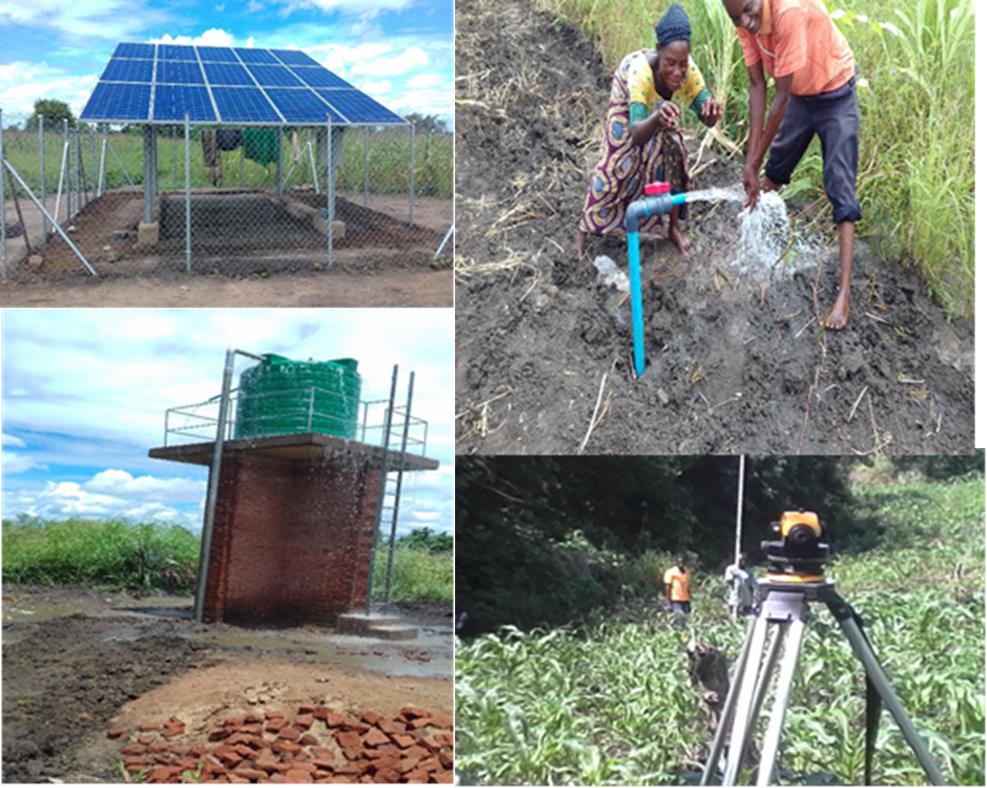

Mchengereza Irrigation scheme (WVM)

### 3.1.2 Rehabilitation of irrigation schemes

Major rehabiliatation works occurred at Bua irrigation scheme in Nkhotakota district where 156 ha has been rehabilitated under SIVAP. Minor rehabilitation took place at Ngalande irrigation scheme where 7 ha was rehabilitated under COOPI.

### 3.1.3 Development of farmer organization

The Department was also involved in several training sessions in the reporting period, where a farmers from different schemes were trained in water management, group dynamics, scheme operation and maintenance and WUA formation. The summary of the training is in the table below.

***Table 5: Trainings Conducted in the ISD***

|  |  |  |  |
| --- | --- | --- | --- |
| ID | Scheme Name | Topic | Beneficiaries |
| 1 | Lifidzi | Wua formation, water management, operation and maintenance | 120 |
| 2 | Kakowa | Wua formation, water management, operation and maintenance | 47 |
| 3 | Ngalande | Wua formation, water management, operation and maintenance | 54 |
| 4 | Nakaleza | Wua formation, water management, operation and maintenance | 54 |
| 5 | Chitsanzo | Wua formation, water management, operation and maintenance | 30 |
| 6 | Mafuka | Wua formation, sustainable land management, operation and maintenance | 22 |
| 7 | Nkhangayawala | Wua formation, water management, operation and maintenance | 45 |

### 3.2 Cumulative irrigation status

The Division had achieved significant area that has been developed and put into utilisation. This achievement has been so due to collaboration with other stakeholders such as NGOs and Government projects and programs such as COOPI, Malawi Lake Basin Program, Total Land Care Illovo Sugar Company, Breen Belt Initiative, Malawi Mangos, and World Vision International. Below is a summary breakdown of the area by technology;

***Table 6: Breakdown of Area Under Irrigation By Technology***

|  |  |  |  |  |  |  |
| --- | --- | --- | --- | --- | --- | --- |
| **Irrigation Technology** | **Number of irrigation sites** | **Area (Ha)** | | **Beneficiaries** | | |
| **Developed** | **Utilized** | **Male** | **Female** | **TOTAL** |
| Gravity-fed irrigation | 32 | 1249 | 874 | 2245 | 2091 | 4526 |
| Motorized pump based | 27 | 11372.8 | 11372.8 | 739 | 1130 | 1869 |
| Treadle pump based | 280 | 1178.5 | 284 | 2406 | 2978 | 5384 |
| Watering cans based | 98 | 28 | 28 | 1134 | 741 | 1875 |
| **TOTAL** | **437** | **13828.3** | **12558.8** | **6524** | **6940** | **13654** |

*Table 7: Summary of Gravity Fed Irrigation Schemes by Water Source*

|  |  |  |  |  |  |  |  |
| --- | --- | --- | --- | --- | --- | --- | --- |
| **Technology** | **Water source** | **Number of Sites** | **Area developed, ha** | **Area utilized for irrigation, ha** | **Beneficiaries** | | |
| **Female** | **Male** | **Total** |
| Gravity Fed | Dam based | 1 | 75 | 62 | 0 | 1 | **1** |
|  | Stream/river | 81 | 1296.7 | 868 | 2165 | 2545 | **4710** |
|  | Impoundments | 17 | 146.9 | 140.4 | 218 | 287 | **505** |
|  | **Totals** | **99** | **1518.6** | **1070.4** | **2383** | **2833** | **5216** |

### 3.2.2 Motorized pump based Irrigation schemes

*Table 8: Summary of Motorized Pump Based Irrigation Schemes by Water Source*

|  |  |  |  |  |  |  |  |
| --- | --- | --- | --- | --- | --- | --- | --- |
| **Technology** | **Water source** | **Number of pumps Installed** | **Area developed, ha** | **Area utilized for irrigation, ha** | **Beneficiaries** | | |
| **Female** | **Male** | **Total** |
| Motorised pump | Boreholes | 11 | 62 | 62 | 241 | 130 | **371** |
| Impoundments | 1 | 5 | 5 | 35 | 20 | **55** |
| Dam | 1 | 3 | 3 | 5 | 20 | **25** |
| Shallow wells | 83 | 107.4 | 61.1 | 278 | 154 | **432** |
| Streams / river | 36 | 237.8 | 139.8 | 602 | 581 | **1183** |
| Lakes | 10 | 156.3 | 140 | 339 | 227 | **566** |
| Wind mills | 0 | 0 | 0 | 0 | 0 | **0** |
| **Totals** | **142** | **571.5** | **410.9** | **1500** | **1132** | **2632** |

### 3.2.3 Treadle pump based Irrigation schemes

*Table 9: Summary of Treadle Pump Based Irrigation Schemes by Water Source*

|  |  |  |  |  |  |  |  |  |
| --- | --- | --- | --- | --- | --- | --- | --- | --- |
| **Technology** | **Water source** | **Number of schemes** | **Number of pumps Installed** | **Area developed, ha** | **Area utilized for irrigation, ha** | **Beneficiaries** | | |
| **Female** | **Male** | **Total** |
| Treadle pump based | Impoundment | 116 | 689 | 365.5 | 212 | 1261 | 1087 | **2348** |
| Dam based | 24 | 229 | 132 | 68.6 | 116 | 323 | **439** |
| Shallow wells | 67 | 487 | 251.3 | 226.5 | 1213 | 775 | **1988** |
| Stream based | 96 | 330 | 261.2 | 239.3 | 1045 | 775 | **1820** |
| Lake based | 56 | 471 | 492 | 430 | 488 | 611 | **1099** |
| **Totals** | **359** | **2206** | **1502** | **1176.4** | **4123** | **3571** | **7694** |

## 3.3 Collaboration with other stakeholders

There has been very good collaboration with various NGOs in the Division in both Salima and Nkhotakota districts. These include Total Land Care, World Vision International, Malawi Lake Basin Program, GIZ, CISP, COOPI, and many more. They contribute positively to irrigation development particularly in solar pumping technology and rehabilitation of existing schemes.

## 3.4 Estate/private irrigation farming

There are also big companies working on irrigation such as Illovo Sugar Company irrigating 7000ha of sugarcane using electrical pumps from Lake Malawi, and Malawi Mangos irrigating 117ha of various fruits using drip irrigation system through pumping, as well as Green Belt Initiative Holdings also pumping its water from Lake Malawi irrigating 523ha. A total of 7640ha is under these companies.

# 4.0 PROGRESS ON DEVELOPMENT PROJECTS/ PROGRAMMES

The Division also implemented development projects and programs such as SIVAP, Support to GBI, AIYAP, MFERP, LDF and others. The achievements have been shown in table

***Table 10 : Progress on Projects and Programs***

|  |  |  |  |  |  |
| --- | --- | --- | --- | --- | --- |
| **NGO/ Project** | **Area dev, ha** | **No. of beneficiaries** | | | **Irrigation technology** |
| **Male** | **Female** | **Total** |
| COOPI | 96 | 276 | 438 | 709 | M/Pump/GF& TP |
| MFERP | 16 | 49 | 85 | 134 | Solar powered,T/pumps,R/D |
| Kafasi | 5 | 17 | 23 | 40 | Solar powered |
| TLC | 108 | 139 | 165 | 139 | Solar powered,R/D,T/pumpsand Motorised |
| Malawi Lake Basin | 3 | 1 | 18 | 1 | Treadle Pump |
| Kindle | 2 | 10 | 34 | 44 | Solar |
| World Vision | 30 | 44 | 71 | 115 | treadle pump, solar |
| ELDS | 0.3 | 1 | 0 | 1 | Solar Pump |
| Afikepo | 0.2 | 2 | 0 | 2 | Stream Diversion |
| AIYAP | 1000 | 1525 | 760 | 2285 | T/pumps and farm inputs |
| THM | 3.2 | 11 | 45 | 56 | T/pumps and farm inputs |
| SIVAP | 540 | 420 | 780 | 1100 |  |
| SGBI (Lifuwu) | 156 |  |  | 325 | Under construction |

**5.0 LESSONS LEARNT**

The Division has learnt many lessons during the period under review. These include delayed project funding to districts directly implementing projects. There is poor coordination between WUA consultant and district staff on farmer capacity program at both Lifidzi and Bua irrigation schemes under SIVAP. Some NGOs just start implementing irrigation projects without involvement of district irrigation staff.

**6.0 CHALLENGES**

1. There is high motor vehicle running and maintenance costs in the districts.
2. The farmers are unable to meet operating and maintenance of irrigation schemes.
3. There is meager, inconsistent and untimely funding for the Department and is negatively affecting the implementation of the planned activities.
4. Heavy rains affecting construction works at Lifuliza and Kaombe and damaged irrigation structures at Lifidzi.
5. Different irrigation structures like gates, hydrants and pipeline need to be maintained at Lifidzi irrigation scheme to maximize utilization of the scheme.
6. There is vandalism of irrigation structures in most irrigation schemes.
7. There is heavy siltation of the weir at the Lifidzi weir.
8. There is poor coordination with different stakeholders. Poor coordination with UMODZI derailed the implementation of the activities at Lifidzi scheme.
9. The fall of army worms affected crop production in most of the irrigation schemes.
10. Land and power sharing disputes between communities and local leaders have led to the lay of civil works at Chilingali.
11. Change of Committee at Dwambazi affected implementation of various activities under AIYAP.
12. Staff houses require maintenance.

